Individual Logbook

Week 14
Dave Sushames
2026
Contents
Table 1
Discussion 1

Table
Category | Hours Completed
Team meetings | 4h 15m
Client meetings
Advisor meetings | 3h 45m
Research
Development
Testing
Documentation | 17h 30m
Logbook preparation | 1
Other
Total hours for this week | 25h 30m
Running total of hours completed for Capstone | 348h 55m

Logbook content notes
Team meetings:
Monday 10-12
Tuesday 12:15 – 1:15: Auditing logs.
Thursday 12-12:30 Olivia and I going over the Gantt chart, updating it with the new dates, and discussing what we’ll be working on next.
Friday 12:15-1pm: Bryce debrief
Client meetings:
Advisor meetings:
Monday 9-10
Monday 2-3: Dax meeting.
Friday 10:30-12:15
Research
See research log
Development
Documentation
Monday 12:30-1pm: Setting up the Academic and Client Closeout reports. Created title page, headers, contents, and first paragraph of both documents.
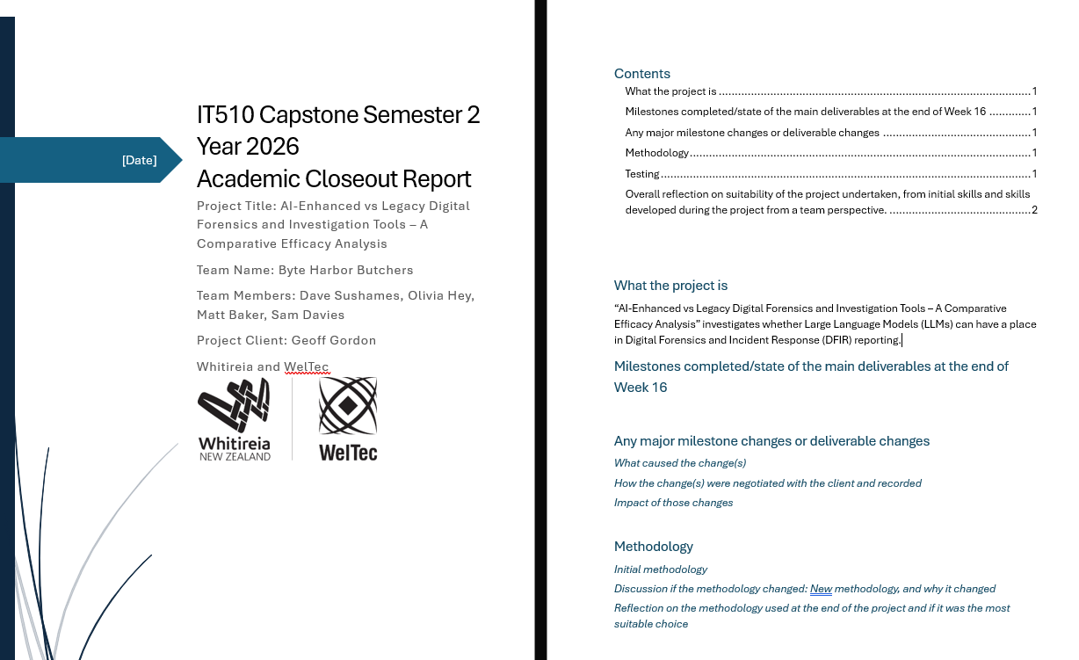
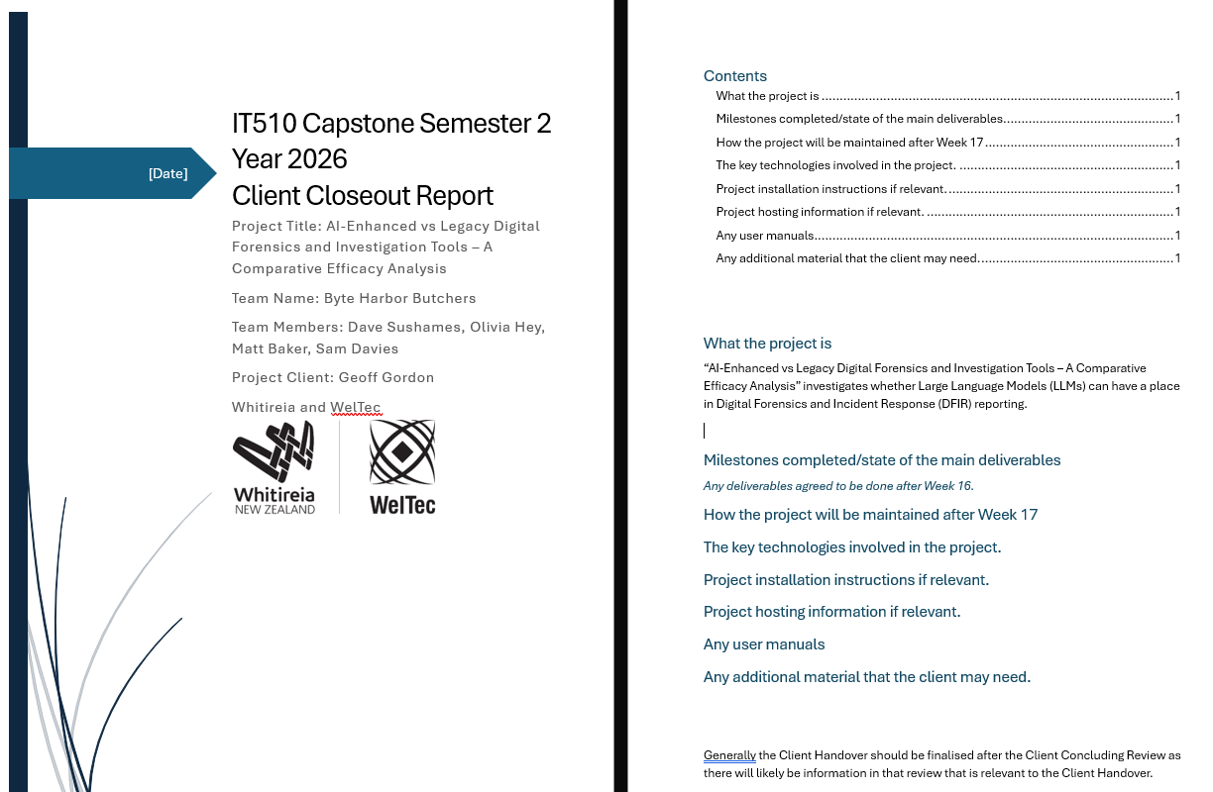

Monday 3-4:30: Comparing human reports and the AI reports for information that was covered. Going through both reports, and summarising all the information that was covered by each.
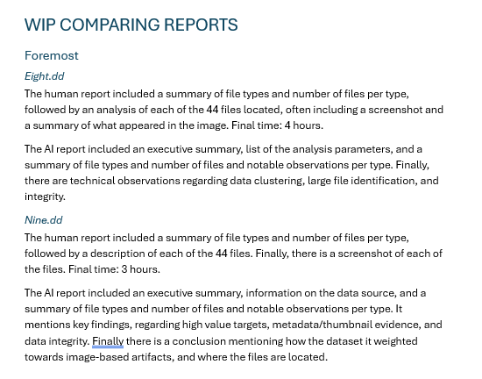
Tuesday 8:45-12:15: Comparing more reports. Decided to switch to a bullet point format, which allows me to detail what each report mentions for each line easier, rather than a large run-on sentence.
Tuesday 1:30-4:15: More report comparisons, moving onto the Wireshark and Nmap sections.
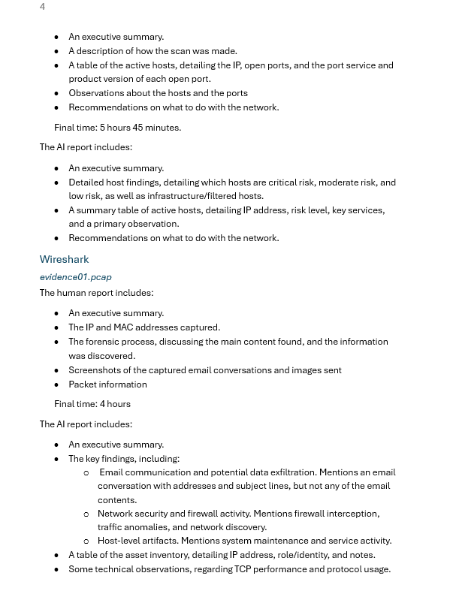
Thursday 12:30-4:30pm: Working on the academic and client closeout reports, getting words down on the pages.
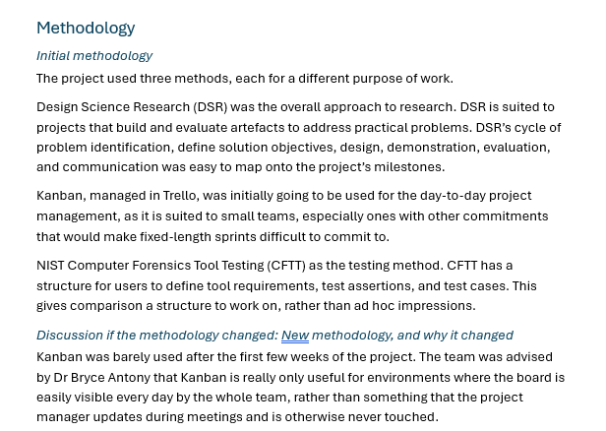
Friday 8:30-10:30: Working on the research report, comparing the human and AI reports, now that Olivia has finished her report on Three.dd. Decided to switch to a table where it compares the different contents of the reports, rather than simply listing everything a report has. This will make it easier to see what a report is missing, especially in comparison to the other reports. Had to decide on a list of criteria that each report “should” have.
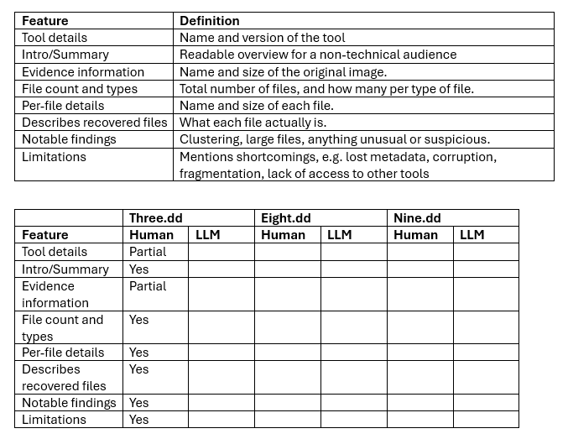
Friday 1:45-5pm: Finishing the report comparisons in the new format. Colour coding to take it more visually apparent. Holding off putting the Nmap and Wireshark tables into the Research Report, as it may influence what Sam and Olivia put into the last Nmap/Wireshark reports that they are currently finishing. 